**15.AWS-NetworkLoadBalancer**

The load balancer for same region not for multiple region

--- 3Types of load balancer

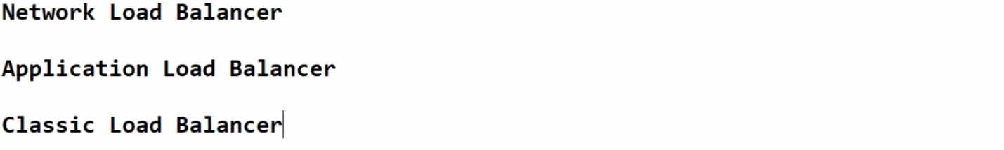

--- we can ignore classic load balancer because it will be removed by Amazon soon.

--- **sed -i "85iline <img src="https://pbs.twimg.com/profile_images/871279549358657538/MjRoDQ5N_400x400.jpg">" /usr/share/nginx/html/index.html** – give like this in a server it will display the image.

**3-TIER APPLICATION LOAD BALANCER**

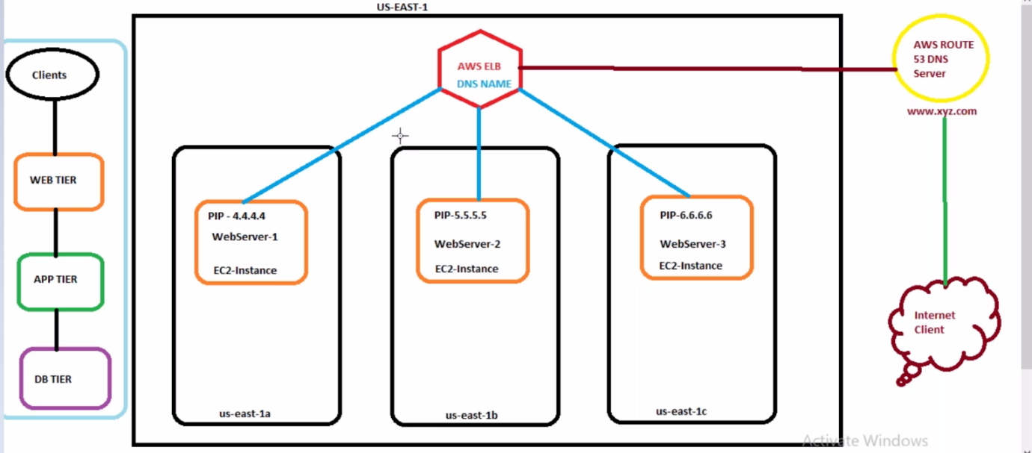

**Network Load Balancer**

In order to create a load balancer. We have to create target group’s first.

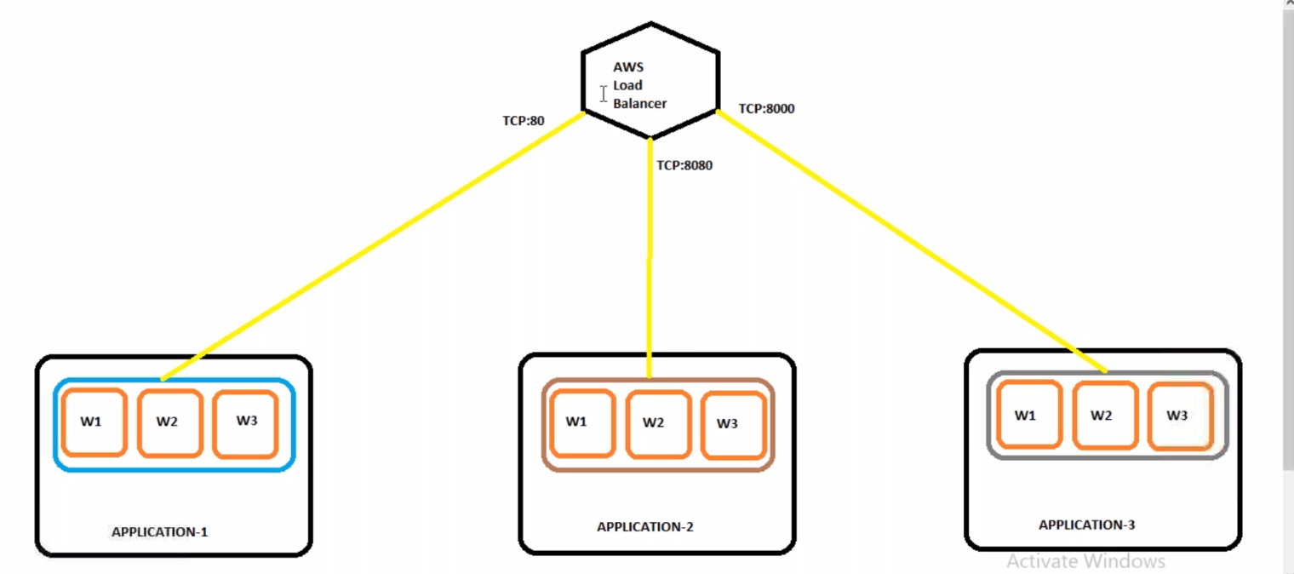

Here all the application machines presented in different target groups and these target groups are connected with load balancer using different poet numbers

**Target group creating**

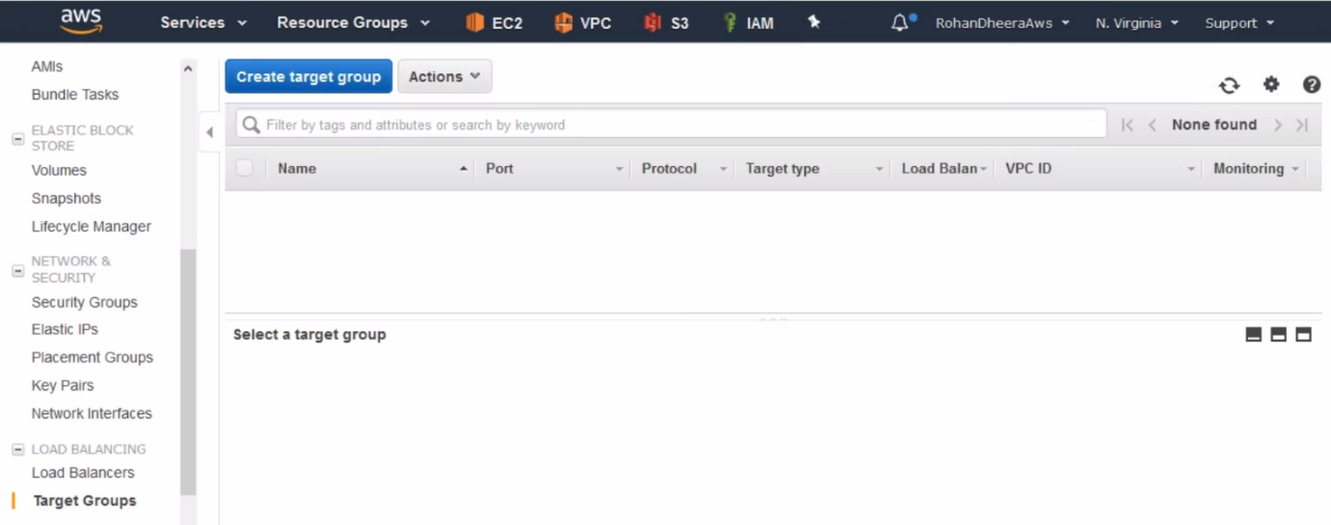

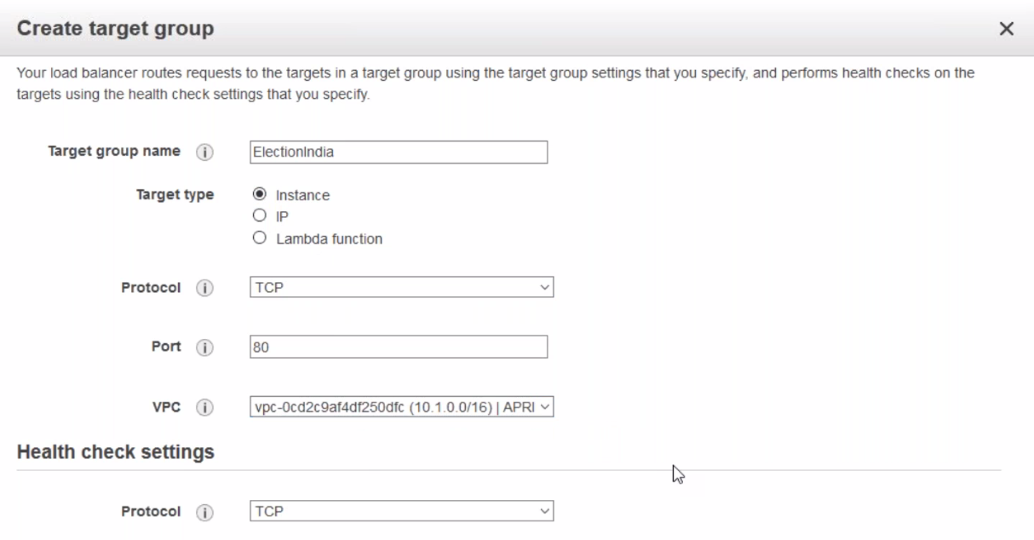

--- click on creating

**Adding targets to target group**

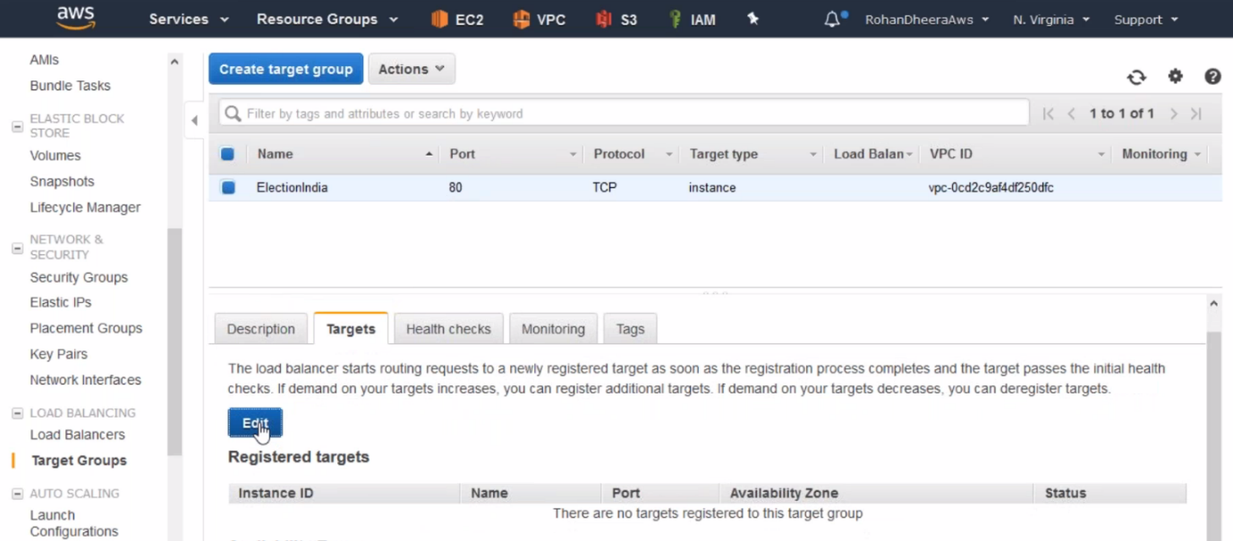

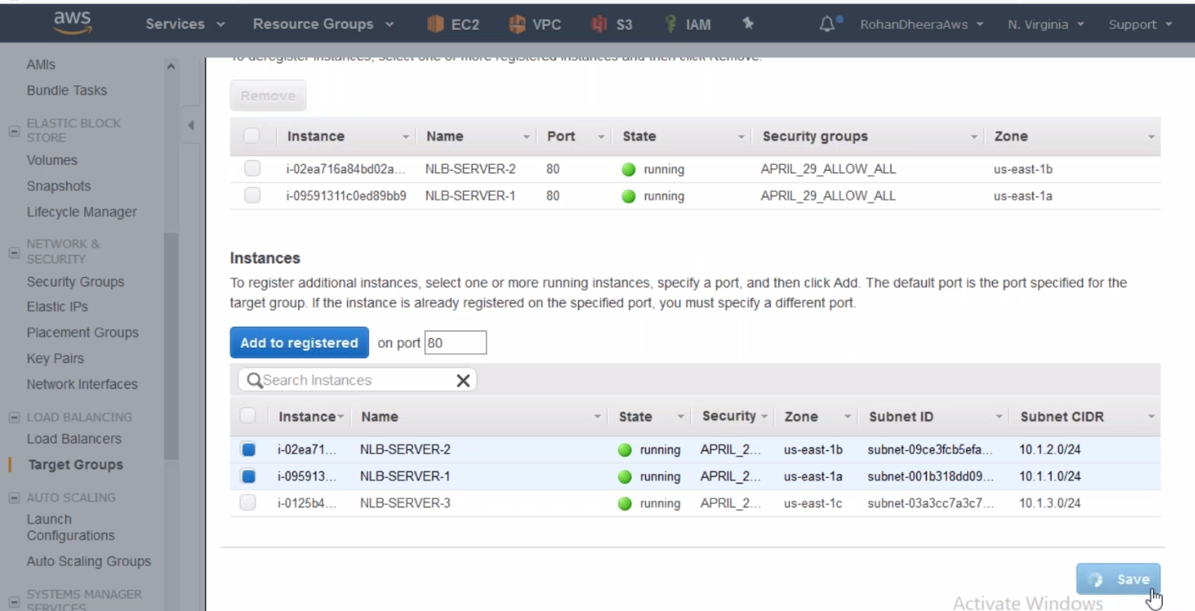

--- here I am only adding 2 machines to the target group.

**Creating Load balancer**

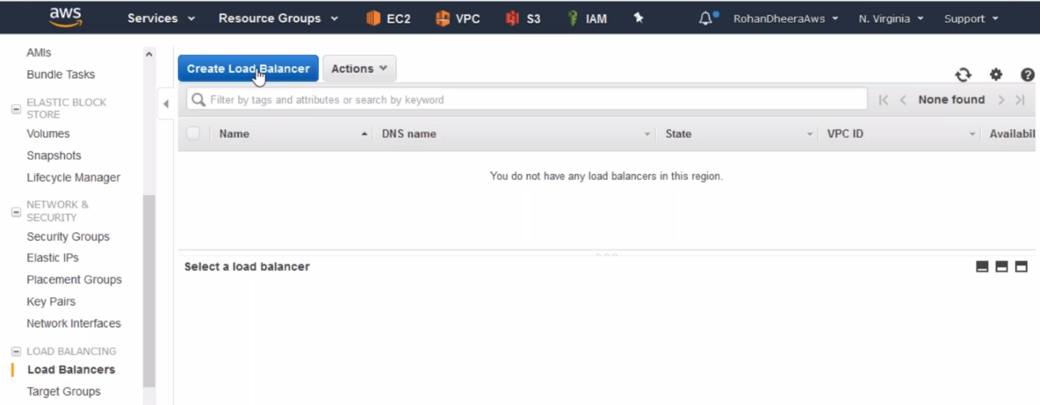

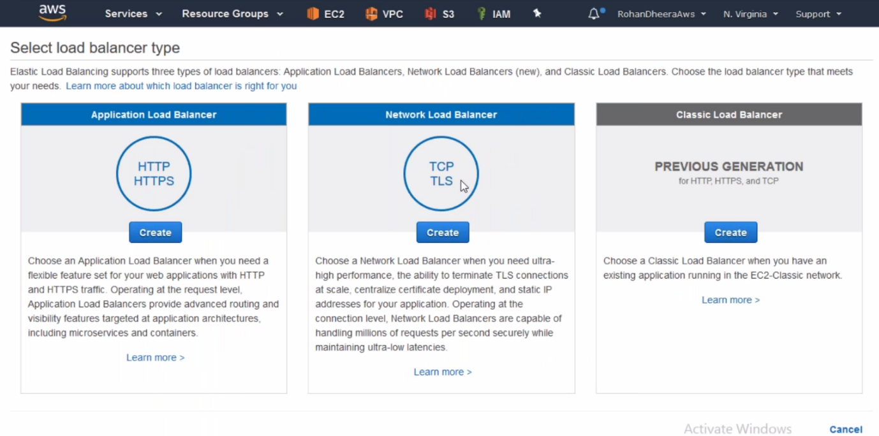

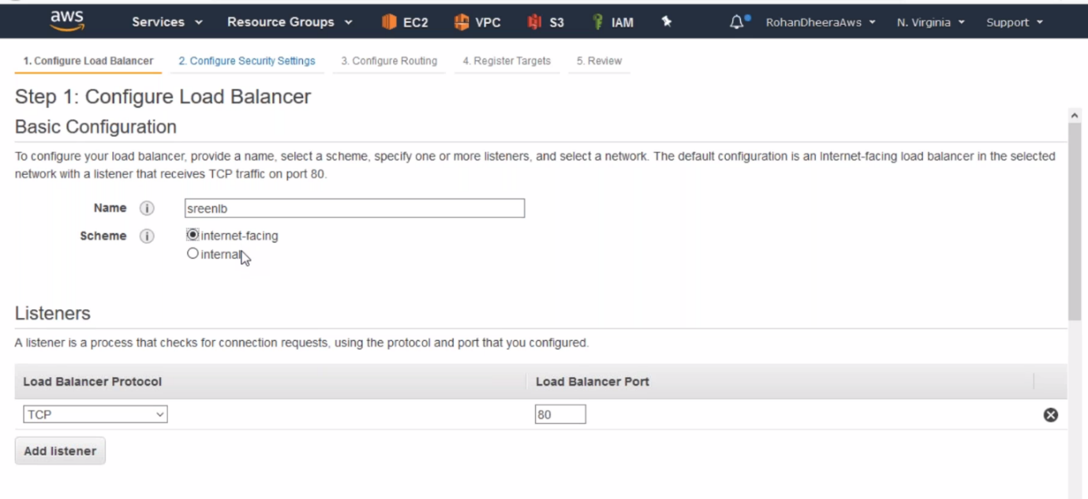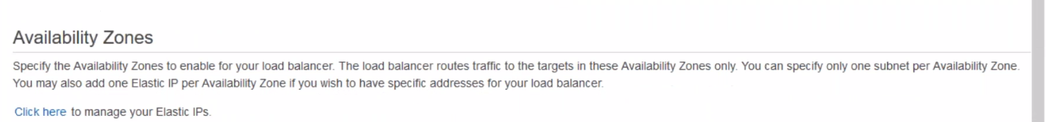

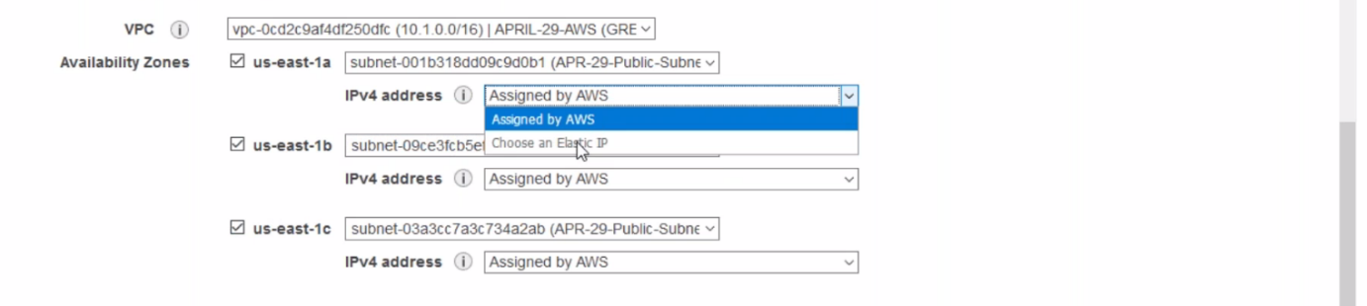

**---** you can assign elastic IP address for your instances also. Once you created the load balancer, you cannot add subnet’s so add as much as subnets before.

--- **QUES I already created a load balancer and I want to add 1d region is it possible to add 1d…?**

In case of application load balancer, you can add the but in case of network load balancer you cannot add the subnets after creation of load balancer.

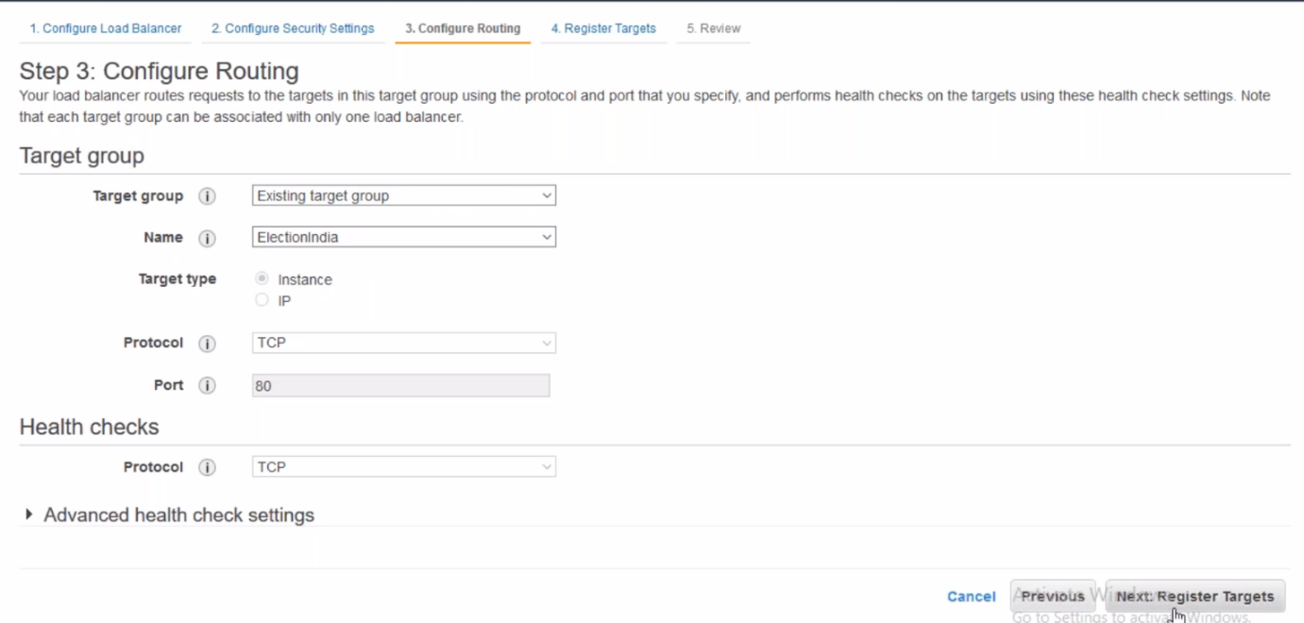

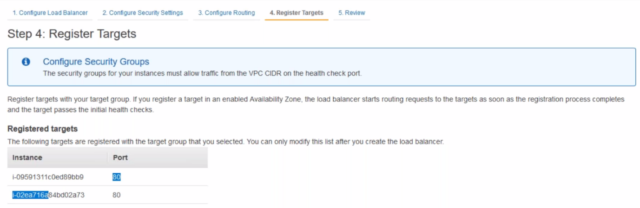

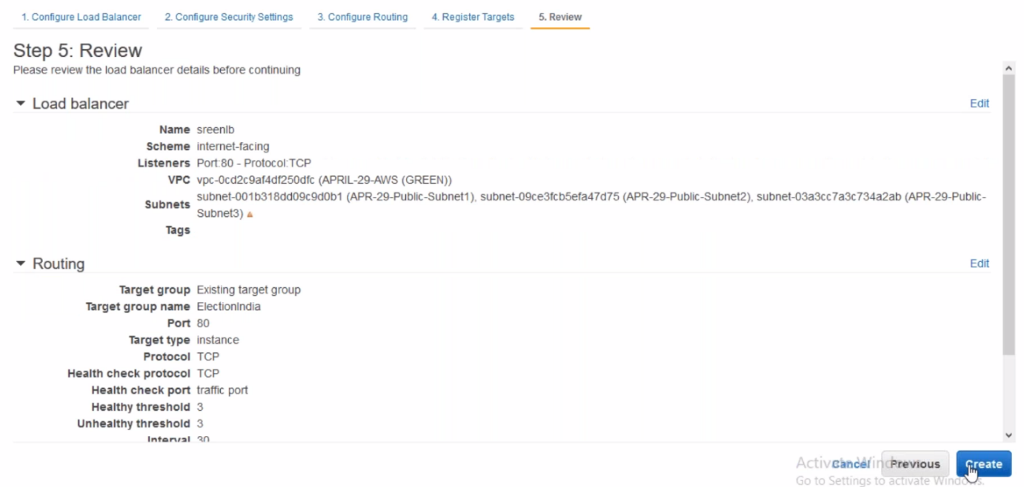

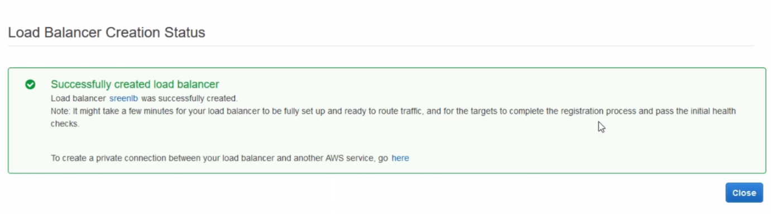

**Saving log files in s3 from load balancer**

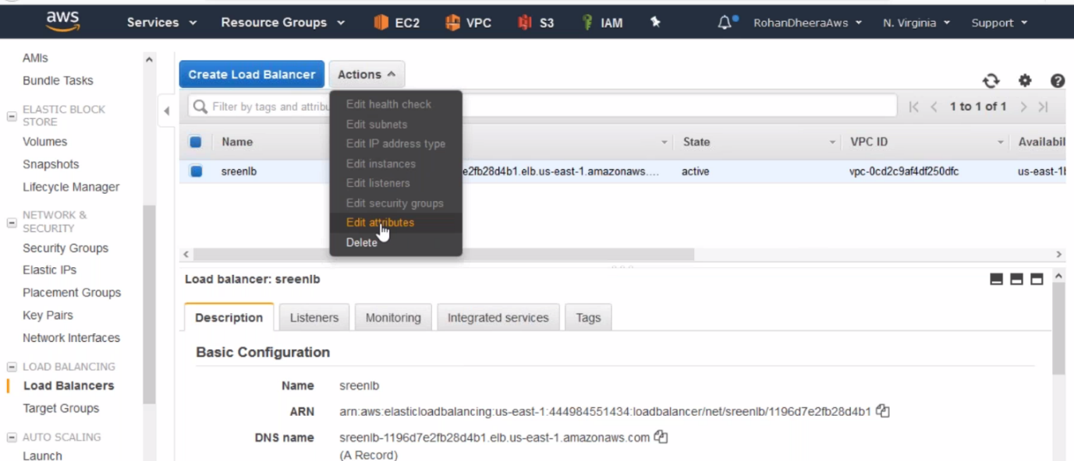

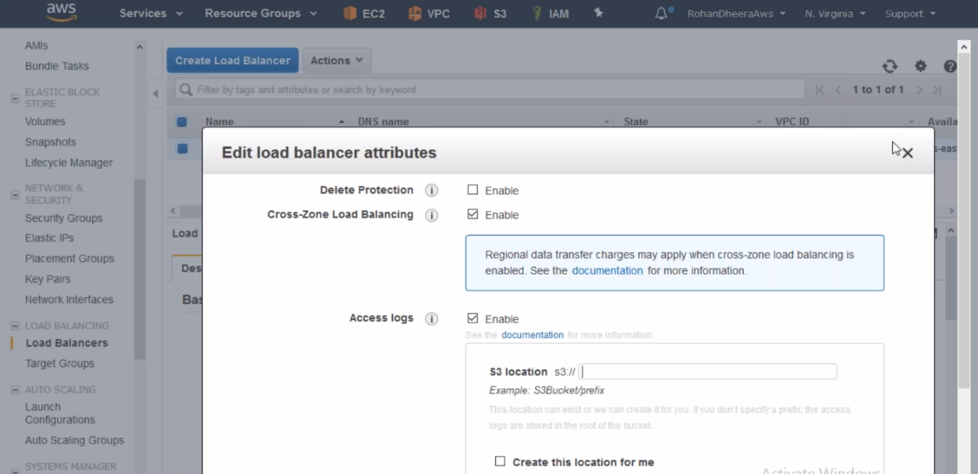

--- all log files saved as zip format in s3, you can download the files for analysing purpose you can use files to spelunk

**Adding 2nd target group to the load balancer**

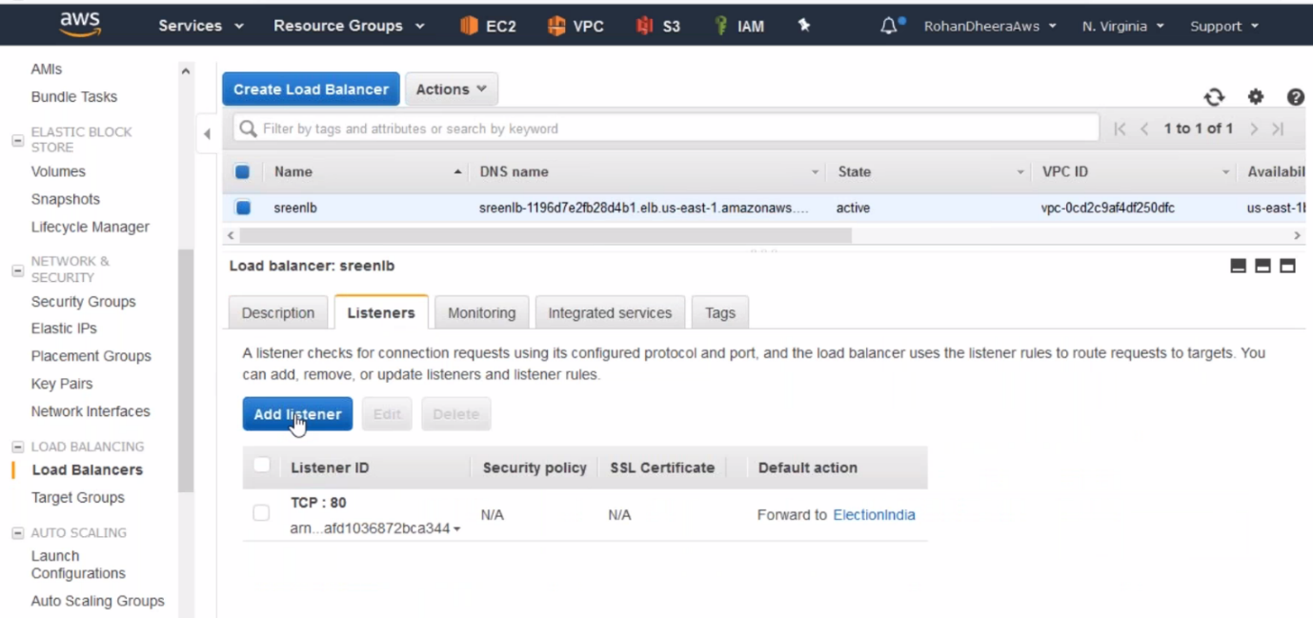

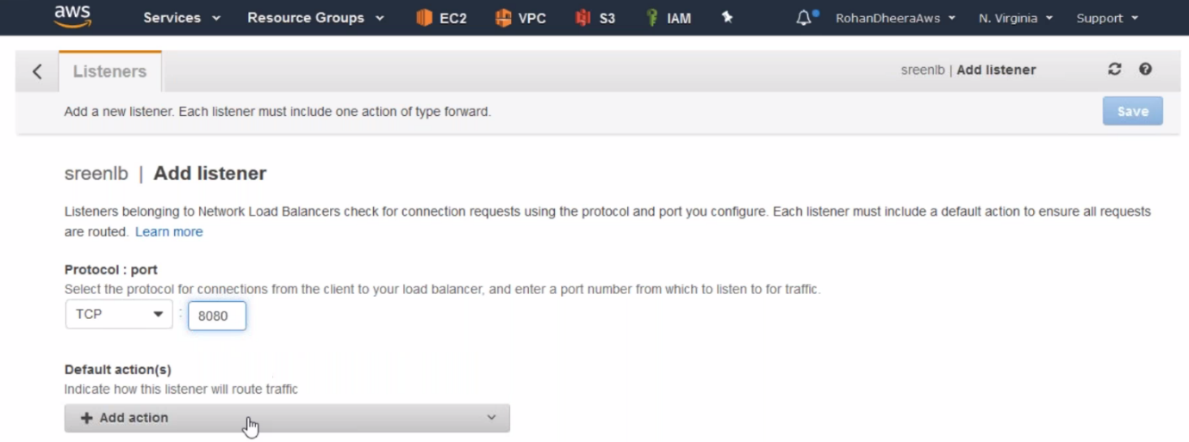



**---** save it.

